Graphs

Many problems are naturally formulated in terms of points and connections between them. For example, an electric circuit has gates connected by wires, an airline map has cities connected by routes, and a program flowchart has boxes connected by arrows. A graph is a mathematical object which models such situations.
A graph is a collection of vertices and edges. An edge is a connection between two vertices (or nodes). One can draw a graph by marking points for the vertices and drawing lines connecting them for the edges, but it must be borne in mind that the graph is defined independently of the representation. For example, the following two drawings represent the same graph:
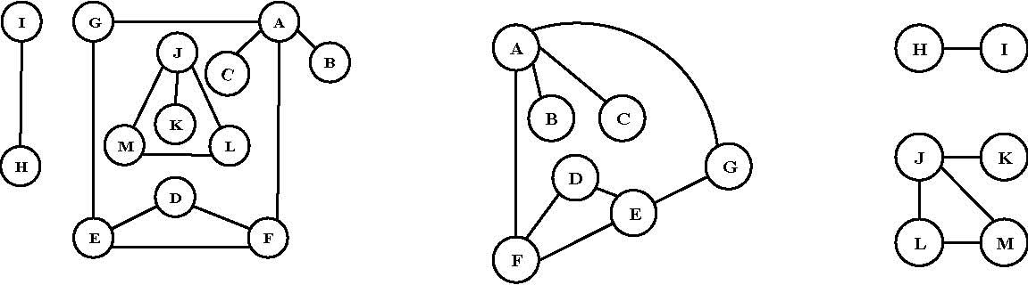
The precise way to represent this graph is to say that it consists of the set of vertices {A, B, C, D, E, F, G, H, I, J, K, L, M}, and the set of edges between these vertices {AG, AB, AC, LM, JM, JL, JK, ED, FD, HI, FE, AF, GE}.
A path from vertex x to y in a graph is a list of vertices, in which successive vertices are connected by edges in the graph. For example, BAFEG is path from B to G in the graph above. A simple path is a path with no vertex repeated. For example, BAFEGAC is not a simple path.
A graph is connected if there is a path from every vertex to every other vertex in the graph. Intuitively, if the vertices were physical objects and the edges were strings connecting them, a connected graph would stay in one piece if picked up by any vertex. A graph which is not connected is made up of connected components. For example, the graph above has three connected components: {I, H}, {J, K, L, M} and {A, B, C, D, E, F, G}.
A cycle is a path, which is simple except that the first and last vertex are the same (a path from a point back to itself). For example, the path AFEGA is a cycle in our example. Vertices must be listed in the order that they are traveled to make the path; any of the vertices may be listed first. Thus, FEGAF and GAFEG are different ways to identify the same cycle. For clarity, we list the start / end vertex twice: once at the start of the cycle and once at the end. A graph with no cycles is called a tree. There is only one path between any two nodes in a tree. A tree on N vertices contains exactly N-1 edges. A spanning tree of a graph is a subgraph that contains all the vertices and forms a tree. A group of disconnected trees is called a forest.
Directed graphs are graphs which have a direction associated with each edge. An edge xy in a directed graph can be used in a path that goes from x to y but not necessarily from y to x. For example, a directed graph similar to our example graph is drawn below.
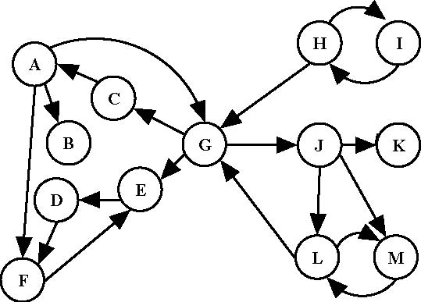
There is only one directed path from D to F. Note that there are two edges between H and I, one each direction, which essentially makes an undirected edge. An undirected graph can be thought of as a directed graph with all edges occurring in pairs in this way. A dag (directed acyclic graph) is a directed graph with no cycles.
We’ll denote the number of vertices in a given graph by V, the number of edges by E. Note that E can range anywhere from V to V² (or 1/2 V(V-1) in an undirected graph). Graphs will all edges present are called complete graphs; graphs with relatively few edges present (say less than V log(V)) are called sparse; graphs with relatively few edges missing are called dense.
It is frequently convenient to represent a graph by a matrix, as shown in the second sample problem below. If we consider vertex A as 1, B as 2, etc., then a “one” in M at row i and column j indicates that there is a path from vertex i to j. If we raise M to the pth power, the resulting matrix indicates which paths of length p exist in the graph. In fact, the quantity M^{p}(i,j) is the number of paths.

The graph data structure has many applications in computer science. We use graphs to represent networks, solve a variety of manufacturing and transport problems, play games, describe 3-D virtual worlds, simulate the dynamic behavior of architectural structures, and so on.

The structure of a graph in a computer program is defined by the physical problem being solved. For example, nodes in a graph may represent cities, while edges may represent airline flight routes between the cities. The shape of the graph arises from the specific real world situation.

A graph structure can be extended by assigning a weight to each edge of the graph. Graphs with weights can be used to represent many different concepts; for example if the graph represents a road network, the weights could represent the length of each road. A directed graph with weighted edges is called a network.

Drawing Graphs

A graph drawing should not be confused with the graph itself (the abstract, non-graphical structure) as there are several ways to structure the graph drawing. All that matters is which vertices are connected to which others by how many edges and not the exact layout. In practice it is often difficult to decide if two drawings represent the same graph. Depending on the problem domain some layouts may be better suited and easier to understand than others.

Data Structures

There are different ways to store graphs in a computer system. The data structure used depends on both the graph structure and the algorithm used for manipulating the graph. Theoretically one can distinguish between list and matrix structures but in concrete applications the best structure is often a combination of both. List structures are often preferred for sparse graphs as they have smaller memory requirements. Matrix structures on the other hand provide faster access but can consume huge amounts of memory if the graph is very large.

Adjacency matrix

An adjacency matrix is an N by N matrix, where N is the number of vertices in the graph. If there is an edge from some vertex x to some vertex y, then the element M(x,y) is 1, otherwise it is 0. If the graph is undirected, the adjacency matrix is symmetric.

Matrix Multiplication

Matrix multiplication is a binary operation that takes a pair of matrices and produces another matrix. The elements of the rows in the first matrix are multiplied with corresponding columns in the second matrix.
